**Coursera Capstone**

**IBM Applied Data Science Capstone**

**Exploring New York’s boroughs to track down the Neighborhood with lowest ranking Japanese restaurant.**

**Introduction:**

Final project explores the base Japanese restaurant in City of New york.New York City comprises 5 boroughs sitting where the Hudson River meets the Atlantic Ocean. At its core is Manhattan, a densely populated borough that’s among the world’s major commercial, financial and cultural centers. Its iconic sites include skyscrapers such as the Empire State Building and sprawling Central Park. Broadway theater is staged in neon-lit Times Square.

New York City's food culture includes an array of international cuisines influenced by the city's immigrant history. [Central](https://en.wikipedia.org/wiki/Central_Europe) and [Eastern European](https://en.wikipedia.org/wiki/Eastern_European) immigrants, especially [Jewish](https://en.wikipedia.org/wiki/Jewish_Americans) immigrants from those regions, brought [bagels](https://en.wikipedia.org/wiki/Bagel), [cheesecake](https://en.wikipedia.org/wiki/Cheesecake#North_America), [hot dogs](https://en.wikipedia.org/wiki/Hot_dog), [knishes](https://en.wikipedia.org/wiki/Knish), and [delicatessens](https://en.wikipedia.org/wiki/Delicatessens) (or [delis](https://en.wikipedia.org/wiki/Delis)) to the city. [Italian](https://en.wikipedia.org/wiki/Italian_diaspora) immigrants brought [New York-style pizza](https://en.wikipedia.org/wiki/New_York-style_pizza) and [Italian cuisine](https://en.wikipedia.org/wiki/Italian_cuisine) into the city, Japanese immigrants brought Japanese cuisine to New York.

**Business Problem:**

The objective of the Capstone project is to analyse and select the best locations in the City of New York to open a new Japanese Restaurant using Data Science Methodology and instruments such as Data Analysis and Data Visualization.

**Data:**

1. New York City Data Containing the boroughs and Neighborhoods.
2. Latitude & Longitude coordinates of those neighborhoods
3. Venue Data related to restaurants.

**Methodology:**

1. Data will be collected from New York city website, cleansed & processed into data frame.
2. Foursquare be used to locate all venues and then filtered by Japanese restaurants.
3. Data will be sorted by the ratings.
4. Finally, data will be visually assessed using graphing.

**Results:**

1. Explore the boroughs of New York city to find out which of the boroughs has highest number of Neighborhoods.

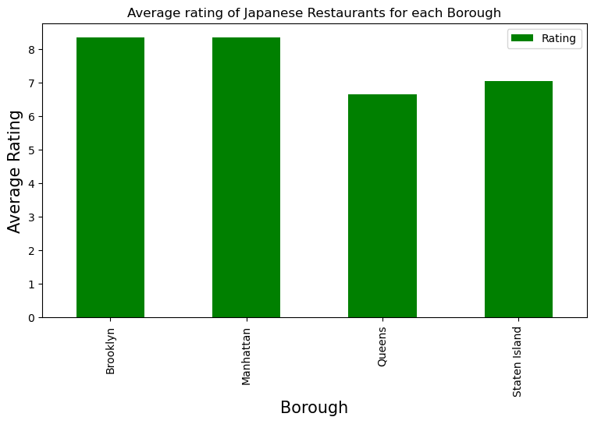

1. Explore the boroughs with highest number of Japanese restaurants: Based on the graph below, Manhattan has the highest number of Japanese restaurants.

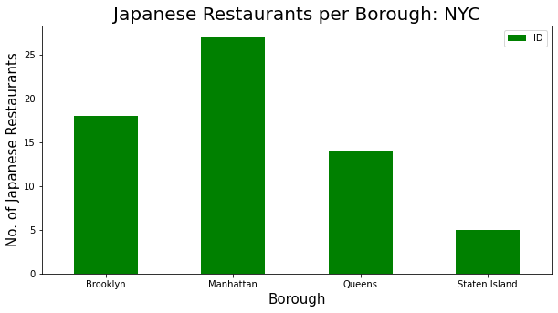

1. Explore which neighbourhood has highest number of Japanese restaurants Manhattan. Based in the graph below, Murray Hill has the highest number of Japanese restaurants.

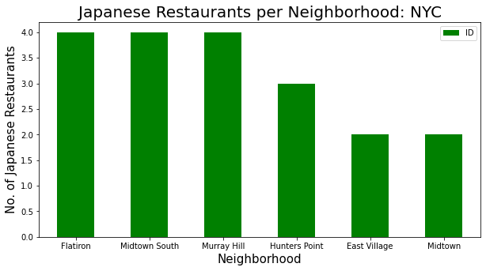

1. Explore which borough has the highest average ranking for Japanese restaurants.



**Top 3 Neighborhoods with highest ranking for Japanese restaurants**

|  | **Borough** | **Neighborhood** | **Average Rating** |
| --- | --- | --- | --- |
| **3** | Brooklyn | Park Slope | 8.9 |
| **1** | Manhattan | East Village | 9.350 |
| **2** | Brooklyn | Cobble Hill | 9.1 |
| **3** | Brooklyn | Downtown | 8.9 |

**Neighborhoods with lowest rankings for Japanese restaurants.**

|  | **Borough** | **Neighborhood** | **Average Rating** |
| --- | --- | --- | --- |
| **1** | Manhattan | West Village | 8.00 |
| **2** | Brooklyn | Prospect Heights | 8.100 |
| **3** | Manhattan | Murray Hill | 8.175 |
| **1** | Queens | Little Neck | 8.00 |

**Discussion**: Based on the above analysis out of 5 Boroughs, Manhattan has the highest number of Japanese restaurants. The Highest-ranking Japanese restaurant is found in East Village Manhattan.

**Conclusion:**

Based on the analysis, we can say West Village & Little Neck neighborhoods have Japanese restaurants with the lowest ranking. I would recommend opening Japanese restaurants in any of those 2 neighborhoods because of less competition.